Q1.
A club, AQA Wanderers, wishes to computerise the records of matches played by its first team so that it can generate statistics on its players. The data requirements are defined below.
In a season, the club’s first team plays against all opposition clubs’ first teams from the same division of the league twice, once at home and once away from home. The date of each match, the start time, opposition team’s name, whether home or away, goals for and goals against are recorded. Each AQA Wanderers’ player has a player identification number and their surname, forenames, date of birth, contact telephone number are recorded.

For each match, fourteen players from a pool of twenty are selected as match players including three substitutes. The player identification numbers of the selected players are to be recorded for each match together with the identification number sewn on the shirt worn (range one to fourteen) so that a player’s first team appearances may be analysed. The goal scorers of AQA Wanderers, if any, in each match must also be recorded together with the number of goals scored by each against the opposition. Players one to eleven start a match but may be substituted by players twelve to fourteen during the match. For any substitution of an AQA Wanderers’ player by another during a match the player identification numbers of both are to be recorded.

Five entities for AQA Wanderers are
Player, MatchPlayer, Match, GoalScorer, Substitution

(a) Using a copy of the partially complete entity relationship diagram shown below as an aid show the degree of five more relationships which exist between the given entities.
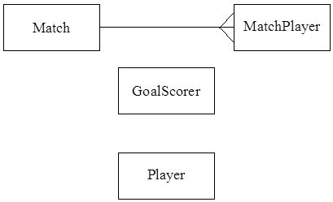
(5)

(b) A relational database is to be used to record the data for one season so that statistics on individual players can be produced at the end of the season. Using the following format
TableName(PrimaryKey, Non-KeyAttributel, Non-KeyAttribute2, etc)
describe tables, stating all attributes, for the following entities underlining the primary key in each case.
(i) Player
Player(Identification Number, Surname, Forename, Date of birth, Contact telephone number)
(2)

(ii) Match
Match(Identification number, First appearances, Goal scorers, Substitutions ID number)
(2)

(iii) GoalScorer
Goal Scorer(Identification number, Opposition, Total goals scored)

(4)
(iv) MatchPlayer
MatchPlayer(Identification number, First appearances)
(3)

(v) Substitution
Substitution(Identification number, Surname, Forename, Date of birth, Contact telephone number, Total goals scored)
(4)
(Total 20 marks)

